Eindopdracht

Mohammed Al Hor

2023-01-19

## 1. (2 points) Design a conceptual model for the analysis of the express company described in the case. Make a logic flow diagram and an activity cycle diagram. Note:the idea is to simulate multiple days. Construct a simulation model specificationon paper in which the simulated days are run sequentially, without any time in between.

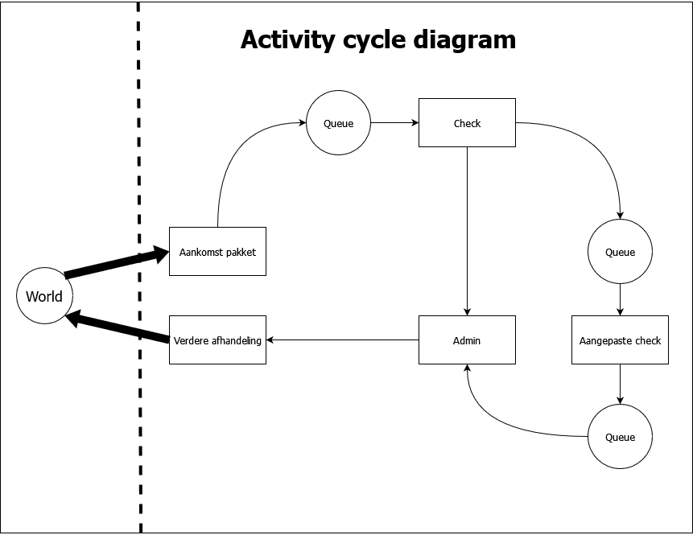

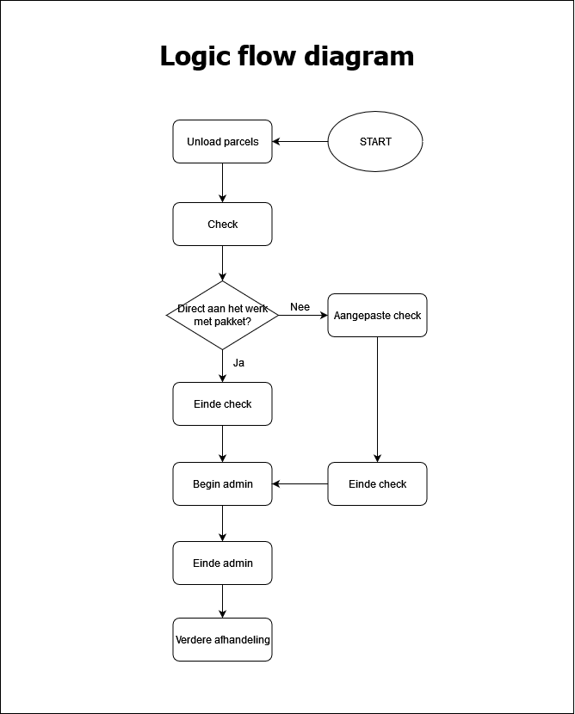

## 2 (a) The mean, and standard deviation of the checking time, admin time, wait time before checking, wait time before admin, and total throughput time of a parcel.

**Express worker mean and sd of checking time in hours:**

**Mean:**

0.08177864 Hours

**Standard deviation:**

0.01593596 Hours

**Express worker mean and sd of wait time in hours:**

**Mean:**

0.03481143 Hours

**Standard deviation:**

0.05387818 Hours

**Admin worker mean and sd of checking time in hours:**

**Mean:**

0.1308929 Hours

**Standard deviation:**

0.03200319 Hours

**Admin worker mean and sd of wait time in hours:**

**Mean:**

0.03481143 Hours

**Standard deviation:**

0.05387818 Hours

**Mean and standard deviation of total throughput of a parcel in hours:**

Mean:

0.2490325 Hours

**Standard deviation:**

0.06722136 Hours

## 2 (b) A density histogram of the total throughput, checking time, admin time, wait time before checking and wait time before admin in the simulation.

**\*All of these values have been converted to hours**

**Histogram of total throughput:**

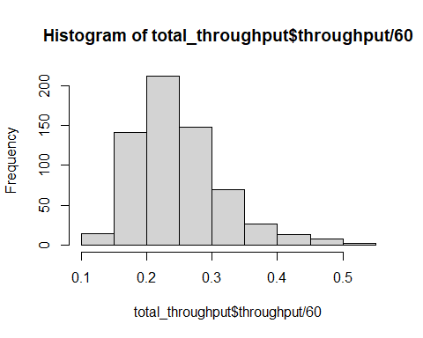

**Histogram of checking time:**

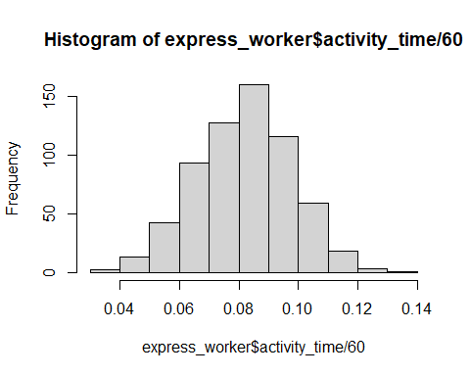

**Histogram of admin time:**

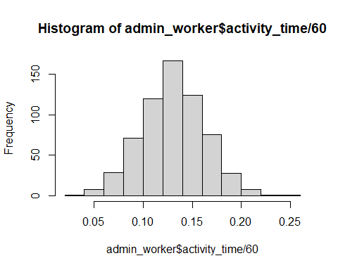

**Histogram of wait time before checking:**

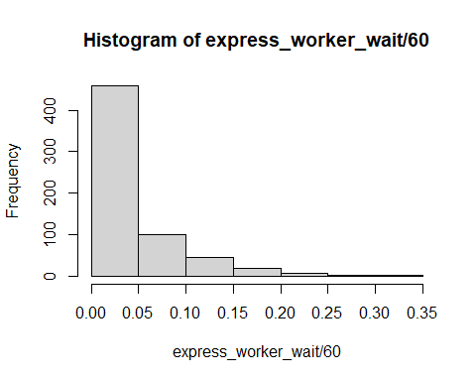

**Histogram of wait time before admin:**

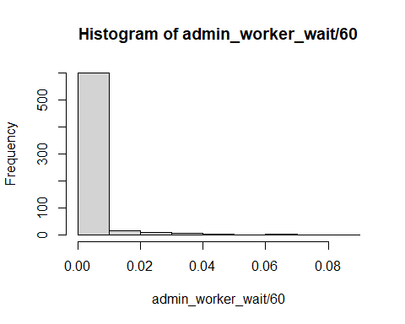

## (c) The proportion of parcels sent out in time. Please also state the simulated amount of parcels and the runtime.

**Proportion of parcels sent out on time:**

100% of parcels are shipped out on time

Total number or parcels simulated:

634 parcels were simulated.

**Total runtime in hours:**

157.8866 hours